Map
- get(key)
  - return the value against key; if not present then null
- getOrDefault(key, default_value)
  - if key not present, return default
- put(key, value)
  - stores/replaces the value
- putIfAbsent(key, value)
  - if key is not present then put; else ignore
- containsKey(key)
  - returns true/false if key present/absent
- remove(key)
  - remove the key
- merge(key, val, (old_val, new_val) -> result)
  - if new value against a key is dependent upon the previous value
  - val will be passed as new_val to lambda function if key already exists
  - val will be inserted against the key key if key is not present; in this case the lambda function will not be called.
  - 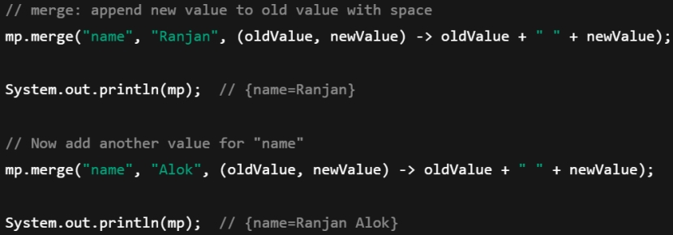
- compute(key, (k, v) -> result)
  - do some operation to the previously present value
  - mp.compute(“count”, (k, v) -> v == null ? 1 : v+1)
  - If count is there then increase the value by 1, else insert 1.
- entrySet()
  - returns the Set of Entry type objects.
  - Set<Map.Entry<K, V>> entrySet() Entry is inner interface inside Map
  - 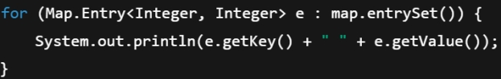
- keySet(), valueSet()
  - returns Set of key and values respectively.
  - 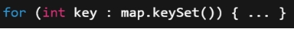
- NOTE
  - compute() and merge() looks similar. But the difference is:
    - In lambda function of compute : key and value is passed
    - In lambda function of merge : old_value and new_value is passed
- F

List
- F
- F
- F
- F
- F

